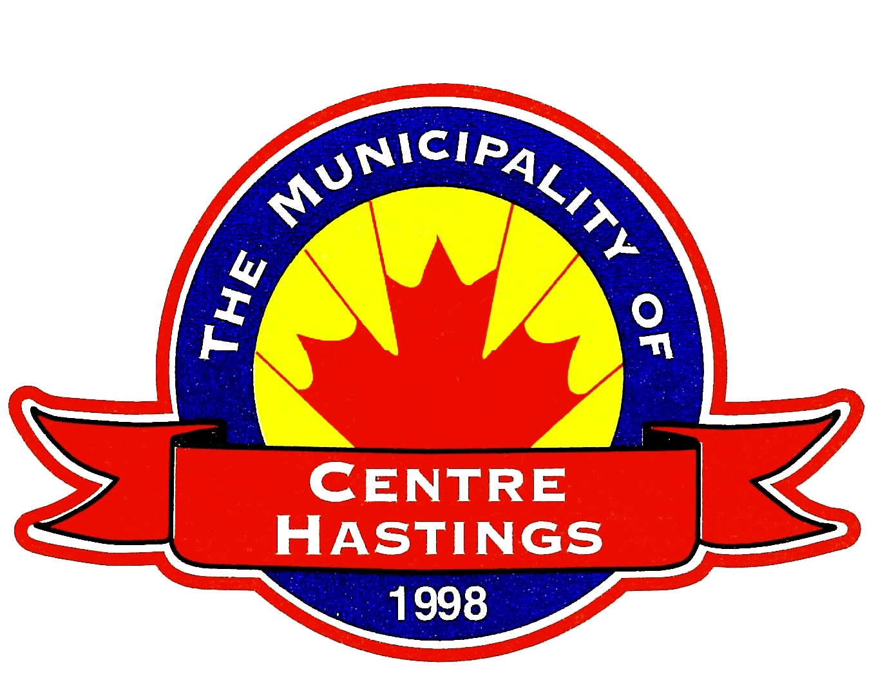
THE CORPORATION OF THE
MUNICIPALITY OF

CENTRE HASTINGS

PHONE: 613-473-4030 7 FURNACE ST., BOX 900
FAX: 613-473-5444 MADOC, ON K0K 2K0
www.centrehastings.com

The Municipality of Centre Hastings invites members of the community to submit an application for the following positions during the 2022-2026 term of Council:
- Centre Hastings Recreation Committee
- Community Development Committee
- Community Improvement Plan Committee
- Centre Hastings Library Board
- Fence Viewers Committee
Available positions will depend on the number of returning community members on these committees. All applications must be received by email or hardcopy to the municipal office by December 16th 2022, at noon and submitted to:

Typhany Choinard, CMO, AOMC
Chief Administrative Officer/Municipal Clerk
7 Furnace St, Madoc, ON K0K 2K0

tchoinard@centrehastings.com

We thank all applicants and advise that only those selected will be contacted. Personal information will be used to determine eligibility for committee appointment and is pursuant to the Municipal Freedom of Information and Protection of Privacy Act. Accessible formats and accommodations are available upon request.

